English exercises | VERB TO BE

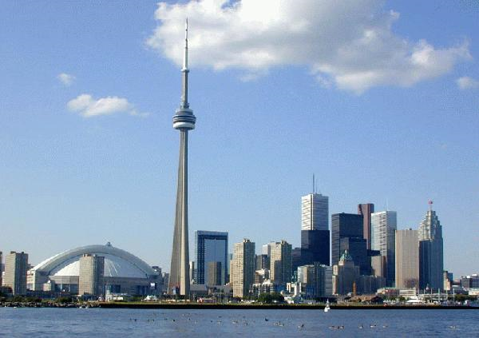
1. Look at this list of participants for a conference in Toronto. Use the information below to help you fill in the gaps, as in the example.

Ms Ishikazi’s first name is Minako. The translator is twenty-eight.
Minako and Alicia are colleagues. Minako and Miho are both Japanese.
The Spanish woman lives with Igor. Igor and Miho are the same age.
Mr Nanni is a salesman.

TORONTO 5TH INTERNATIONAL INFORMATION TECHNOLOGY CONFERENCE

Name | Minako 1  Ishikazi | Igor  Teploukhin | Claudio  Nannj………………4 | Alicia  Lopez | Miho  Ikuta
Company | ibm  ……………. 2 | Telefonica | LRC | IBM | Sony
Job | Systems  analyst | Engineer | Salesman | translator  ……………5 | Designer
Nationality | Japanese | Russian | Italian | Spanish | Japanese  ……………..6
Residence | Barcelona | Madrid  ……………..3 | Rome | Madrid | Tokyo
Age | 25 | 30 | 42 | 28 | 30  ……………..7

2. Answer these questions based on exercise 1.
Verb To be

I am / I’m (sou /estou)
You are / you’re (és / estás)
She is / she’s (é / está)
He is / he’s (é / está)
It is/ it’s (é / está)

We are / we’re (somos / estamos)
You are / you’re (são / estão)
They are / they’re (são / estão)

1. Where is Igor from? Russian

2. What nationality is Alicia? Spanish

3. How old is Claudio? 42

4. Where does Miho live? Tokyo

5. Who do Minako and Alicia work for? ibm

3. Choose the correct PRESENT TENSE form of the verb TO BE (AM – IS – ARE) for each sentence:

a. Where are…………… Messi from?
b. These are_________ my friends.
c. Robert are _________ sick.
d. His tests ________ very difficult.
e. How …………your sister?
f. My parents are not rich, but my aunt ________.
g. My sister and I ________ twins.
h. _______ you happy today?
i. ______ it raining?
j. Pelotas _______ really wet. It has been raining since 1pm.

